Project Design Phase
Problem - Solution Fit Template

Problem–Solution Fit Template
Problem–Solution Fit means finding a customer’s real problem and creating a solution that solves it effectively.
Purpose:
1.Solve the customer’s problems.
2.Make customers accept the solution faster.
3.Improve communication and marketing.
4.Build customer trust by solving important problems.
5.Understand the customer’s situation and improve t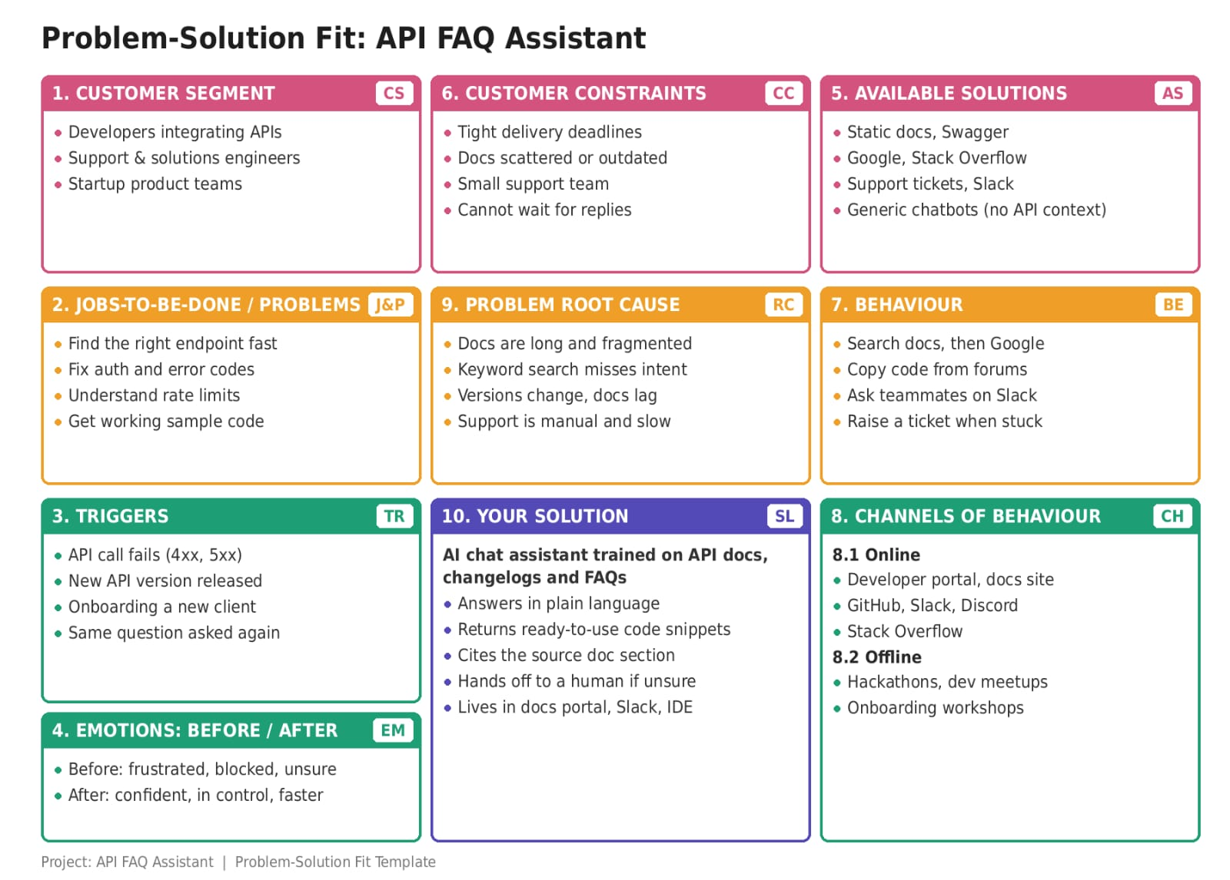he solution.

